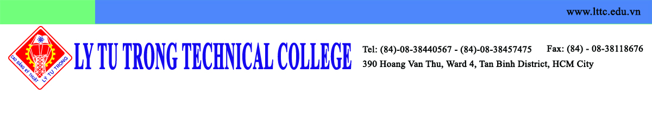
Dear Dr. Seman PYO, Director of Institute of IALE,

On behalf of Ly Tu Trong Technical College Ho Chi Minh City, I am writing to confirm that we are going to Korea from 29th November, 2015 to 6th December 2015 as the study tour to visit the campus of universities such as KUNSAN, DONGGUK and may be KOOKMIN.
It is my great honor to visit Kunsan National University on 2th December 2015 and sign MOA as our plan. The delegation as follow:

1. Mr. Pham Ngoc Thanh, Vice Director of Department of Education and Training of Ho Chi Minh City
2. Mr. Pham Huu Loc, Rector of Ly Tu Trong Technical College Ho Chi Minh City
3. Ms. Nguyen Ngoc Trang, Dean of Scientific Management and International Cooperation Office – Ly Tu Trong Technical College Ho Chi Minh City
4. Mr. Do Cong Thanh, Official of Ly Tu Trong Training Center
5. Mr. Nguyen Phu Thuong Luu, Lecturer

I am looking forward to continuing to cooperate with you to make valuable contributions to the technical education in both schools and the students could get great benefit from this cooperation.

Best regards,

Dr. Pham Huu Loc
Rector
Ly Tu Trong Technical College Ho Chi Minh City

